39129t
5 November 2018

TeknosPro are coatings of choice for PaintTech Training Academy

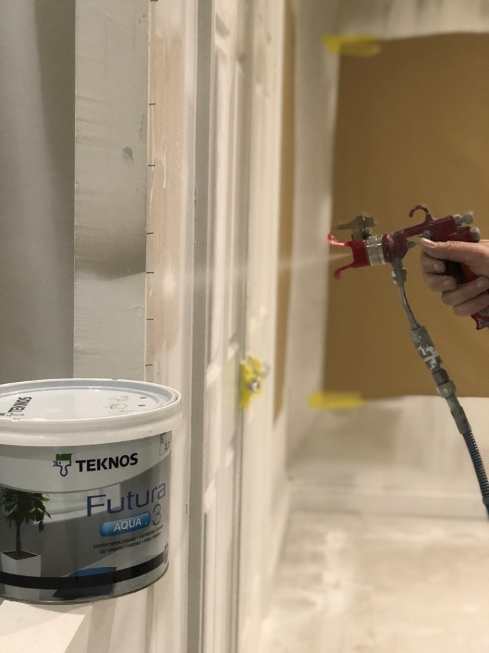

The PaintTech Training Academy has been using TeknosPro paints for over a year. The academy teaches painters and decorators how to get the most from their equipment while enhancing their skills. Based in Surrey, the company offers courses across Kent, Lancashire, Exeter and Ireland.

TeknosPro’s hard-wearing Futura Aqua paints were the coatings of choice for the PaintTech Training Academy’s recent spray application course. Lyndsey Crump, project planner for the Academy and sister company PaintTech Decorators, commented, “We especially liked using the Futura Aqua 3 primer as it was easy to work with and gave good results.” Futura Aqua 3 is an adhesion primer for exterior and interior wood and metal, including furniture, doors, windows and kitchen cabinets. It is toy standard, touch-dry in one hour and can be over-coated in three hours.

The PaintTech Training Academy will be using TeknosPro paints for a spray application demonstration at the National Painting & Decorating Show, showcasing a selection of products from the TeknosPro portfolio including Futura Aqua 3.

For further information on TeknosPro, contact 01608 688925 or visit www.teknos.com/en-GB/professionals.

-ends-

Notes to editor

Teknos is a global coatings company with operations in more than 20 countries in Europe, Asia, and the USA. Approximately 1,800 people are employed and the net sales for 2017 was EUR 384 million. Teknos is one of the leading suppliers of industrial coatings with a strong position in retail and architectural coatings. Teknos wants to make the world last longer by providing smart, technically-advanced paint and coating solutions to protect and prolong. Teknos always works in close cooperation with customers. The company was established in 1948, and is one of Finland’s largest family-owned businesses.

Teknos GBI is a leading supplier of water-based coatings. Teknos paints are high-quality, low odour with sustainability at their core. Over the past 25 years, the company has specialised in factory-finished joinery with a niche and growing customer base in metal coatings, and now it also has a strong following for its multi-surface brushing paints for professional decorators. Established in the UK since 1991, it is part of The Teknos Group. The Teknos Group has a unique history, experience and culture which are enshrined in the Teknos GBI approach. The company’s values of creativity, persistence and fairness, permeates all that Teknos does so that its offering goes beyond paint; Teknos’ professionalism and experience will solve your coatings problems. For further information, visit www.teknos.co.uk.

With Compliments:-
Alison Relf
Taylor Alden Ltd
Unit 2, Temple Place
247 The Broadway
London
SW19 1SD
Tel: 020 8543 3866
Email: alison@tayloralden.co.uk

