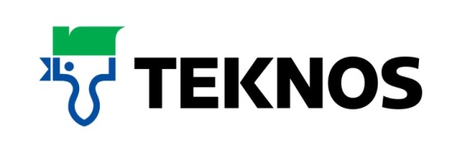
38844t
9 March 2018
The durable water based alternative to oil eggshell paints
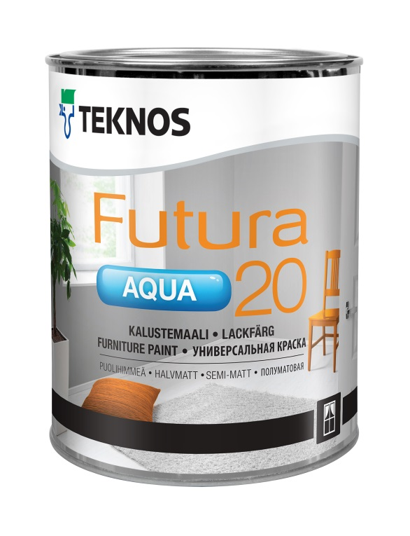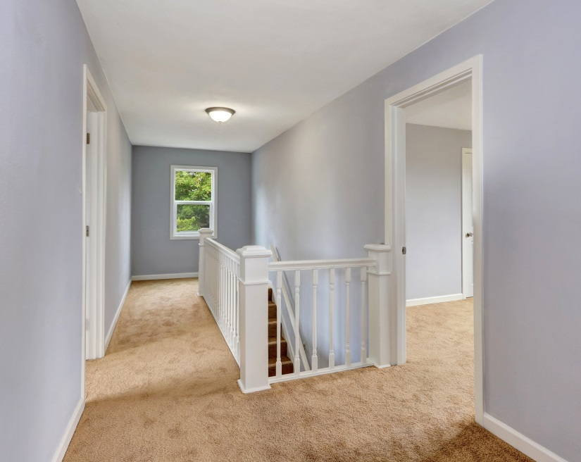

Ideal for use on wood and metal surfaces inside and outside, the Futura Aqua portfolio of waterborne urethane alkyd based interior and exterior finishes from TeknosPro, the expert in professional coatings, provides varying sheen levels with Futura Aqua 20 offering semi-matt, Futura Aqua 40 semi-gloss and Futura Aqua 80 gloss. The paints can be tinted to all Teknos colour shades and also available is the versatile Futura Aqua 3 primer. Package sizes are 0.9, 2.7, 9 litres.

Suited to professionals requiring a hand-applied brush finish that flows easily with few brush marks, it provides a very low sheen top coat and incredibly durable surface.

The paints are environmental-friendly with low VOC levels and can be used for a wide range of applications including interior doors, window casements, cabinets, mouldings, panels, staircase railings and radiators. It is also suitable for use outdoors on primed window casements and doors.

The modern pigments used in the paint disperse evenly through the paint and provides excellent resistance to weather and UV rays, and they retain their colour and gloss over time. The paint may be thinned with water and is easy to apply by brush, roller and spray, which makes the application effortless. The surface is dust free after one hour and through-dry after two to three days.

One happy customer is Jan Jankowski of leading kitchen painter, JJ Painting Services, who comments: “I needed an extremely durable paint for a recent job. Teknos Futura Aqua 20 applied beautifully and, once cured, was very tough. I did the finger nail test by constantly trying to scratch away at the surface but there were no visible marks, which is not the case with most water based paints. Teknos Futura Aqua 20 is the water based alternative to oil eggshells, I’m very impressed!”

-ends-

Notes to editor

Teknos is a global coatings company with operations in more than 20 countries in Europe, Asia and the USA. It employs approximately 1,700 people. Teknos is one of the leading suppliers of industrial coatings with a strong position in retail and architectural markets. Teknos develops smart, technically advanced paint and coating solutions which protect and prolong the life of buildings, wood and metal. Teknos always works in close cooperation with its customers. It was established in 1948 and is one of Finland’s largest family-owned businesses.

For further information contact 01608 688925 or www.teknos.co.uk.

With compliments:

Alison Relf
Taylor Alden Ltd
Unit 2, Temple Place
247 The Broadway
London
SW19 1SD
Tel: 020 8543 3866
Email: alison@tayloralden.co.uk

