

38748t

1 March 2018

**TeknosPro products shine in the renovation of an 18th Century Cottage**

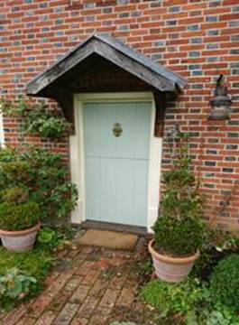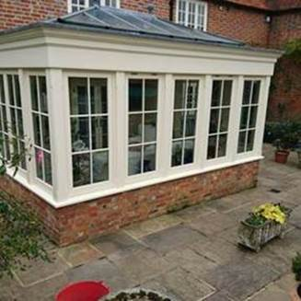

[TeknosPro](https://www.teknos.com/en-GB/professionals/) is a range of multi surface paints and coatings which have been developed for professional decorators. They are based on low odour, quick drying, water-based technology and can be used on various surfaces.

A recent renovation of an eighteenth century cottage in Chobham, Surrey was completed by Nick Sammut from [Rushmoor Painting and Decorating](https://www.rushmoorpainting.co.uk/) who had been asked by his customer to use TeknosPro products.

The cottage had fifteen rotten window frames that needed renovating and repairing; the oak had not been protected adequately by previous paints and therefore the customer, who had already selected a TeknosPro top coat, asked that the primer was from the same portfolio. Supplier of Teknos products, [Holman Paints](http://holmanpaints.co.uk/), which is based in Swindon, also recommended TeknosPro products to the contractor, leading Nick to use [Futura Aqua 3](https://www.teknos.com/en-GB/website/sweden/sweden-ac/mobelfarger-ac/futura-aqua--3/), a TeknosPro primer, to coat the oak sealed windows. The benefit of using this waterborne, full-matt, alkyd based adhesion primer was that it allows the exterior wooden surfaces to expand and contract in changing weather conditions.

The front door of the cottage was painted with [Futura Aqua 40](https://www.teknos.com/en-GB/website/sweden/sweden-ac/mobelfarger-ac/futura-aqua-40/) and the oak windows were painted with Teknos Aquatop. The semi-gloss paint is best used on top of Futura Aqua 3 primer and the Teknomix 50 Tinting System enables customers to choose from a wide range of colours; from opaque colours, [Teknos Colour Mode](https://www.teknos.com/en-GB/professionals/colours/) collection, British Standard and European Colour collections such as RAL and NCS.

When asked what he thought of TeknosPro products, contractor Nick commented, “They’re really good products. I have also used [Timantti 7](https://www.teknos.com/en-GB/website/global/global-ac/interior-ac/timantti-7/) on another project for the conservatory walls, kitchen walls and ceilings.” Timantti 7 is a waterborne matt special acrylate suitable for use in both dry and humid areas and can be used in conjunction with the [Timantti 3](https://www.teknos.com/en-GB/website/uk/uk-ac/timantti-3/) primer.

Nick will use definitely use TeknosPro products again; “I have already priced many new jobs based on TeknosPro products. We are known for producing top quality work which would not be possible without quality products. You put your whole reputation on the line with the products you use. When you find brands like TeknosPro, you have faith in them performing the way they should without letting you or your reputation down.”

For further information, contact 01608 688925 or visit [www.teknos.co.uk](http://www.teknos.co.uk).

-ends-

**Notes to editor**

Teknos is a global coatings company with operations in more than 20 countries in Europe, Asia and the USA. It employs approximately 1,600 people. Teknos is one of the leading suppliers of industrial coatings with a strong position in retail and architectural markets. Teknos develops smart, technically advanced paint and coating solutions which protect and prolong the life of buildings, wood and metal. Teknos always works in close cooperation with its customers. It was established in 1948 and is one of Finland’s largest family-owned businesses.

With Compliments:-

Alison Relf

Taylor Alden Ltd

Unit 2, Temple Place

247 The Broadway

London

SW19 1SD

Tel:  020 8543 3866

Email: [alison@tayloralden.co.uk](mailto:alison@tayloralden.co.uk)