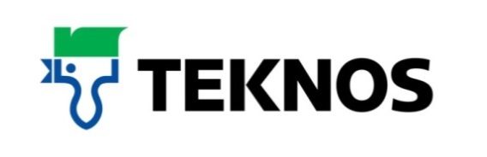

38659
26 October 2017

Teknos, a natural fit for Russell Paints
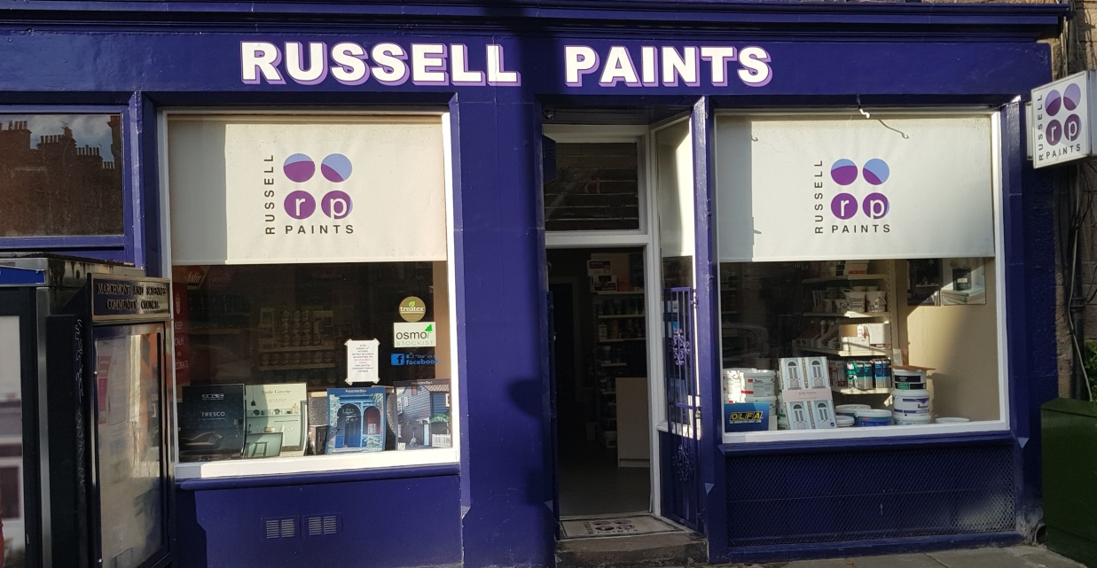

As an independent, family-owned business that has been established in Edinburgh for almost 40 years, Russell Paints saw Teknos as a perfect fit with its customer base and started stocking the company’s wood finishing products some three years ago. Since then, many customers have chosen Teknos over other brands and returned for repeat orders.

Russell Paints has grown to be probably the biggest truly independent paint merchant in Edinburgh and the Lothians since opening in 1976 and now services the trade, commercial and DIY markets. The staff pride themselves on the high level of customer service and wide knowledge that they have gained over the years. Being independent, they can offer impartial advice on the products most suitable for individual needs.

Teknos has a proven track record in timber protection with its spray applied coatings and, prompted by customer enquiries, Russell Paints saw stocking brush-applied coatings as a natural progression. Housebuilders were frequently requesting Teknos products to undertake maintenance to windows and doors that had been factory-finished but had been damaged, either through poor handling on site or during work such as the application of render coatings to walls.

To ensure the highest levels of quality are maintained, the staff at Russell Paints have been given in-store training in all the Teknos products stocked. While the main market for TeknosPro is professionals, the waterborne paints are frequently offered to DIYers because of their ease of application and environmental credentials.

For Russell Paints, Teknos is an attractive proposition due to the range of products available and the flexibility of the tinting system which is capable of providing customers with thousands of readily available colour options. Added to this, the heritage of the company is appealing as there is a feeling that, if the paints are good enough for the harsh Scandinavian climate, they must be suitable for the Scottish market.

Jim Johnston, Russell Paints’ managing director, comments: “Teknos was a natural fit for us and, in the time we’ve stocked the product, all the feedback has been positive. The paints are easy to use and the quality of the finish is excellent. For exterior protection they are, without a shadow of a doubt, our go to company and we’re now servicing a vast number of decorators who use the products. From our perspective as a distributor, Teknos offers very good support both technically and in the colour aspects of their products.”

For further information, contact 01608 688925 or visit www.teknos.co.uk.

-ends-

Notes to editor

Teknos is a global coatings company with operations in more than 20 countries in Europe, Asia and the USA. It employs approximately 1,600 people. Teknos is one of the leading suppliers of industrial coatings with a strong position in retail and architectural markets. Teknos develops smart, technically advanced paint and coating solutions which protect and prolong the life of buildings, wood and metal. Teknos always works in close cooperation with its customers. It was established in 1948 and is one of Finland’s largest family-owned businesses.
With compliments:

Alison Relf
Taylor Alden Ltd
Unit 2, Temple Place
247 The Broadway
London
SW19 1SD
Tel: 020 8543 3866
Email: alison@tayloralden.co.uk
.

