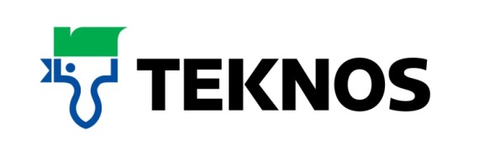
38592
8 August 2017

Choose a paint that lasts with TeknosPro’s Futura Aqua 40

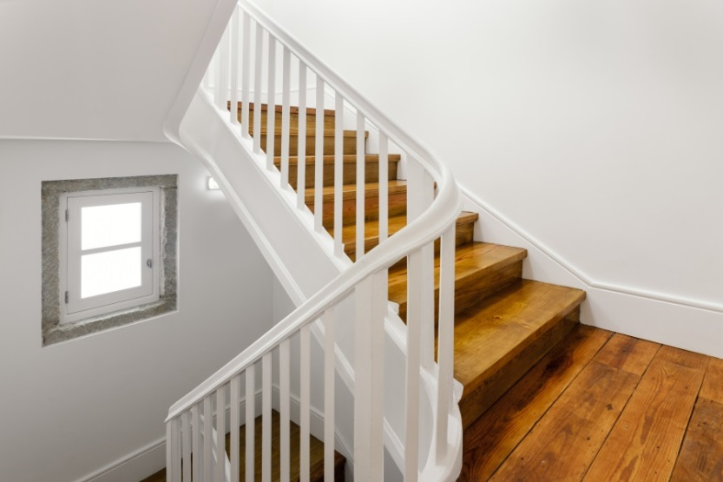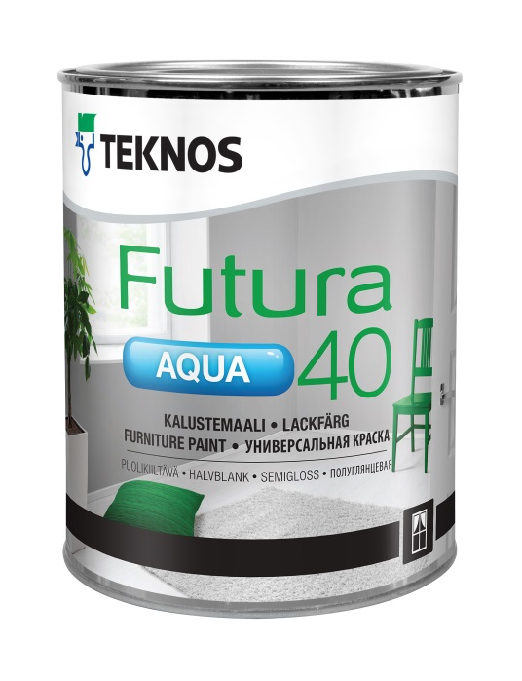

The answer for maintaining windows, doors, conservatories and other joinery, Teknos Futura Aqua 40 is a waterborne urethane alkyd based paint with a highly durable semi-gloss finish. Suitable for interior and exterior use, the product is designed for professionals and joinery manufacturers requiring a spray, brush or roller applied finish that flows easily on wood, metal and building board surfaces.

Teknos Futura Aqua 40 does not drip, is easily tinted to all Teknos colour shades, can be thinned with water and used in conjunction with the versatile Futura Aqua 3 primer. Quick drying times mean the surface is dry after one hour and through-dry after two to three days. Weather and UV resistant, the product utilises modern pigments that disperse evenly through the paint and provide lasting colour so its appearance is retained over time.

Typical interior uses for Futura Aqua 40 include windows, doors, furniture, cupboards, banisters, panel surfaces and radiators. Outdoors, it is suitable for items such as primed window frames, doors, furniture, handrails and fence structures.

Environmentally friendly with low VOC levels and low to no odour, Teknos Futura Aqua 40 complies fully with European VOC emission standards and REACH regulations. It does not contain lead, chrome or other heavy metal additives so is safer for decorators and helps ensure indoor air quality. Equipment is easily washed with detergent and warm water.

The Futura Aqua portfolio of waterborne finishes provides varying sheen levels with Futura Aqua 20 offering semi-matt and Futura Aqua 80 gloss. Package sizes are 0.45 0.9, 2.7, 9 litres.
For further information, contact 01608 688925 or visit www.teknos.co.uk.

-ends-

Notes to editor
Teknos is a global coatings company with operations in more than 20 countries in Europe, Asia and the USA. It employs approximately 1,700 people. Teknos is one of the leading suppliers of industrial coatings with a strong position in retail and architectural markets. Teknos develops smart, technically advanced paint and coating solutions which protect and prolong the life of buildings, wood and metal. Teknos always works in close cooperation with its customers. It was established in 1948 and is one of Finland’s largest family-owned businesses.

With compliments:

Alison Relf
Taylor Alden Ltd
Unit 2, Temple Place
247 The Broadway
London
SW19 1SD
Tel: 020 8543 3866
Email: alison@tayloralden.co.uk

