38611
6 September 2017

Teknos impresses at Templeogue Decor
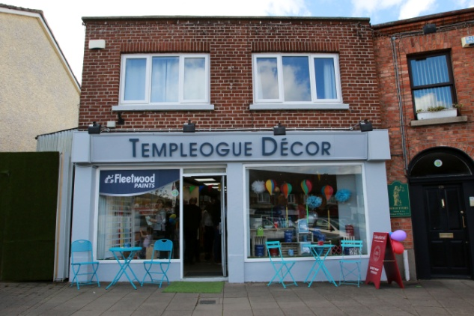

Impressed by the Teknos paint range when previously working as decorators, the family team behind Templeogue Decor proudly stocks Teknos products in their new paint, wallpaper and decor store in Templeogue, a suburb with a village feel in SW Dublin.

The van Loon family grew up in Templeogue and the surrounding area so, as locals, Nicola, her brother Stephen and her father Gerry decided to pool their experience in paint, carpentry and business to take over the village hardware store and relaunch it with a fresh take on interiors focused on personal service.

Templeogue Decor offers expert advice on interior and exterior projects, along with colour consulting and inspiration in store and in customers’ homes. It supports trade customers with technical knowledge and solutions matched by an extensive range of top quality products.

Stephen and Gerry van Loon had been using Teknos products for kitchens and other high traffic areas as well as for exterior projects and were impressed by the superior quality, durability and finish offered by the finishes. They particularly saw the value of the products for trade customers due to the extensive colour range and versatility, with the paint being suited to hand painting and use with spray equipment.

The family has initially chosen the Teknos products that it believes will best suit their key customer base and is looking to increase the range as interest grows. Templeogue Decor’s current stock includes the waterborne Futura Aqua 20, 40, 80 as well as Futura 3 primer and the oil-based Futura 40; the waterborne varnishes Helo Aqua 20, 40, 80; Silkosan Facade and Silkosan Gel emulsion products; and the wood stains Woodex Aqua Solid and Woodex Eko.

Nicola van Loon comments: “Teknos has been really excellent at helping us all along. The USP of our shop is our ability to offer advice and problem solving and, time and again, the Teknos range provides the solutions our customers are looking for. In high traffic areas in particular, you need a finish that is bulletproof and it was the quality, durability and versatility of the products that drove our decision to stock them. It’s a really fantastic product and, when we pick the right Teknos product for the job at hand, you definitely see satisfied customers.”

For further information contact 01608 688925 or www.teknos.co.uk.

-ends-

Notes to editor

Teknos is a global coatings company with operations in more than 20 countries in Europe, Asia and the USA. It employs approximately 1,700 people. Teknos is one of the leading suppliers of industrial coatings with a strong position in retail and architectural markets. Teknos develops smart, technically advanced paint and coating solutions which protect and prolong the life of buildings, wood and metal. Teknos always works in close cooperation with its customers. It was established in 1948 and is one of Finland’s largest family-owned businesses.

With compliments:

Alison Relf
Taylor Alden Ltd
Unit 2, Temple Place
247 The Broadway
London
SW19 1SD
Tel: 020 8543 3866
Email: alison@tayloralden.co.uk

