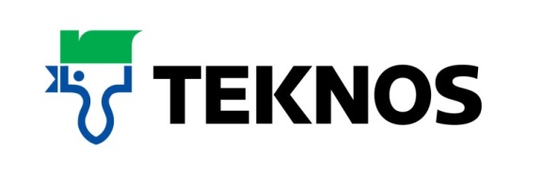

38590
10 August 2017

Teknos products proving popular at Holman Specialist Paints

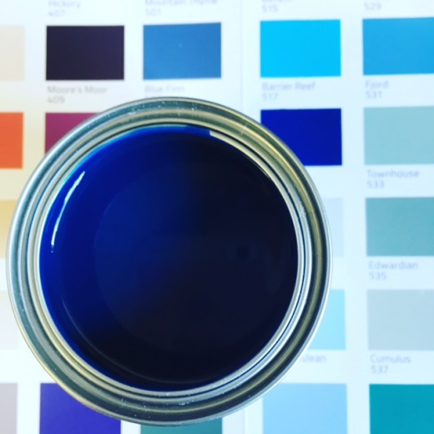

Stocking and selling coatings from only European manufacturers that are recognised as leaders in their field, Holman Specialist Paints in Swindon is now offering the full range of TeknosPro decorative products. These include coatings for walls, woodwork and masonry which are already proving popular among customers due to their durability and versatility. The large and diverse client base ranges from the homeowner to professionals in the building, maintenance, furniture and metalworking industries, as well as architects and specifiers.

Teknos products are designed and manufactured especially for the professional while Holman Specialist Paints has extensive experience in supplying coatings to customers all over the UK and internationally. The two companies are working together closely to bring Teknos decorative coatings to existing clients and new customers.

Customers particularly love the mid sheen of Teknos Futura Aqua 20 which offers the perfect balance between a matt and a semi-matt finish. It is not only the company’s customers who are pleased, Holman Specialist Paints has tried and tested the products in its headquarters, using both the Teknos Futura Aqua and TeknosPro interior wall paint to freshen the company’s offices, with just two coats transforming the space.

Among the ways in which Teknos decorative coatings outshine some of the other product ranges sold by Holman Specialist Paints is through the savings gained by the competitive trade prices that can be passed on to customers.

For some larger commercial projects, such as schools, hospitals and care-homes, Holman Specialist Paints provides Teknos Timantti wall paints. These are extra durable, can withstand frequent washing and wiping and are suitable for higher-traffic areas. With the addition of Timantti Clean, which has an anti-microbial additive, buildings with special hygiene considerations can be well catered for.

Paul Hague, owner of Holman Specialist Paints, comments: “We’re very selective of which manufacturers we work with to ensure our customers receive only the best quality coating products. Teknos has a well-established reputation for supplying high-quality coatings to the UK joinery industry so we jumped at the opportunity to become a stockist for this decorative range. From the very offset, we’ve been extremely pleased and grateful for the high level of service and support that we’ve received from Teknos and we’ve had an incredibly positive response from all our customers who have tried Teknos products.”

For further information, contact 01608 688925 or www.teknos.co.uk.
-ends-

Notes to editor

Teknos is a global coatings company with operations in more than 20 countries in Europe, Asia and the USA. It employs approximately 1,700 people. Teknos is one of the leading suppliers of industrial coatings with a strong position in retail and architectural markets. Teknos develops smart, technically advanced paint and coating solutions which protect and prolong the life of buildings, wood and metal. Teknos always works in close cooperation with its customers. It was established in 1948 and is one of Finland’s largest family-owned businesses.

With compliments:

Alison Relf
Taylor Alden Ltd
Unit 2, Temple Place
247 The Broadway
London
SW19 1SD
Tel: 020 8543 3866
Email: alison@tayloralden.co.uk
.

