

39253t

4 December 2018

**Rajvel Deco proud to be TeknosPro distributor**

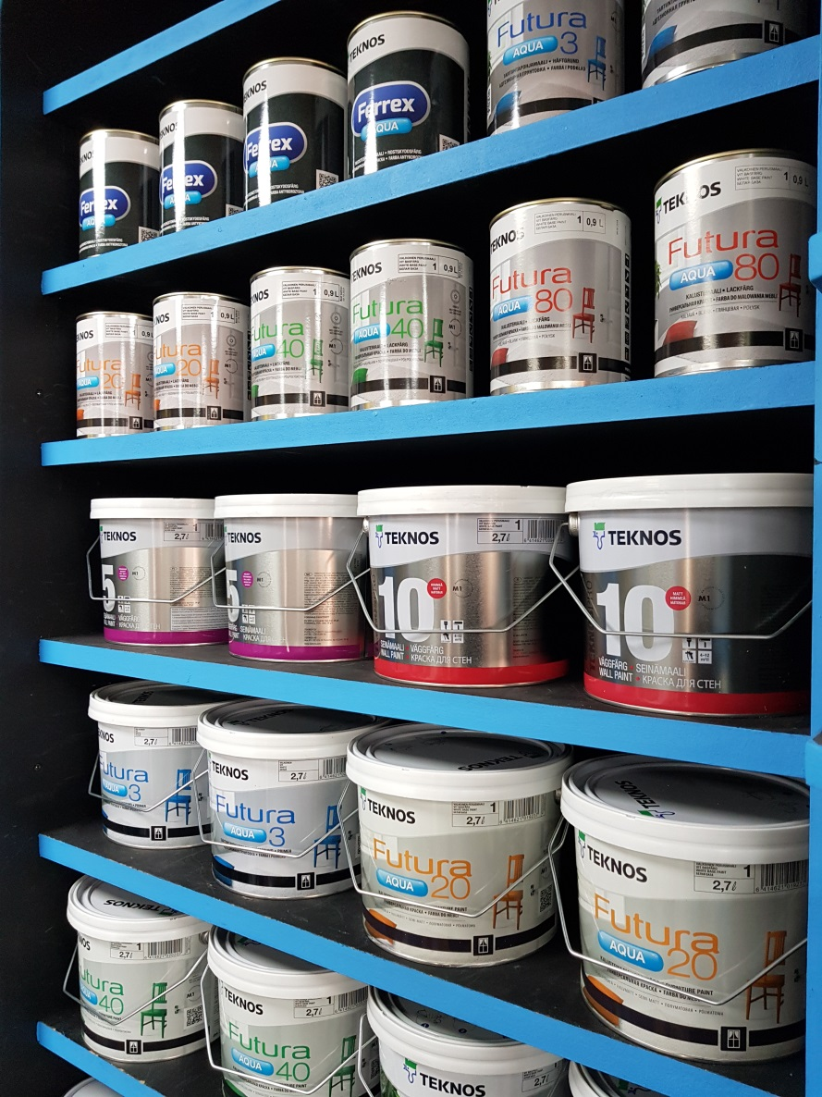

Widely recognised for its diverse accessories and spray coating products, [Rajvel Deco](http://www.rajvel.com/rdl), part of the Rajvel Group, is proud to add [TeknosPro](https://www.teknos.com/en-GB/professionals/) coatings to its growing collection.

Established in 2007, Rajvel Deco offers customers coatings for wood, metal and glass, in-house paint mixing and colour matching services, and a wealth of other products, providing both retail and trade customers with a one-stop shopping experience.

Rajvel Deco’s Bhavesh Bhuva commented, “We are really pleased to be a distributor of TeknosPro. There is a growing demand for TeknosPro products across North West London and we’re pleased to be able to offer these quality products directly to our customers at competitive prices.”

Known for high quality sustainable water-based coatings with low odour, Teknos is one of the leading suppliers of industrial coatings and is developing a strong position within the decorative coatings sector too.

For further information on TeknosPro, contact 01608 688925 or visit [www.teknospro.co.uk](http://www.teknospro.co.uk). For further information on Rajvel Deco Limited, visit [www.rajvel.com/rdl](http://www.rajvel.com/rdl)

-ends-

**Notes to editor**

Teknos is a global coatings company with operations in more than 20 countries in Europe, Asia, and the USA. Approximately 1,800 people are employed and the net sales for 2017 was EUR 384 million. Teknos is one of the leading suppliers of industrial coatings with a strong position in retail and architectural coatings. Teknos wants to make the world last longer by providing smart, technically-advanced paint and coating solutions to protect and prolong. Teknos always works in close cooperation with customers. The company was established in 1948, and is one of Finland’s largest family-owned businesses.

Teknos GBI is a leading supplier of water-based coatings. Teknos paints are high-quality, low odour with sustainability at their core. Over the past 25 years, the company has specialised in factory-finished joinery with a niche and growing customer base in metal coatings, and now it also has a strong following for its multi-surface brushing paints for professional decorators. Established in the UK since 1991, it is part of The Teknos Group. The Teknos Group has a unique history, experience and culture which are enshrined in the Teknos GBI approach. The company’s values of creativity, persistence and fairness, permeates all that Teknos does so that its offering goes beyond paint; Teknos’ professionalism and experience will solve your coatings problems. For further information, visit [www.teknos.co.uk](http://www.teknos.co.uk).

With Compliments:-

Alison Relf

Taylor Alden Ltd

Unit 2, Temple Place

247 The Broadway

London

SW19 1SD

Tel:  020 8543 3866

Email: [alison@tayloralden.co.uk](mailto:alison@tayloralden.co.uk)