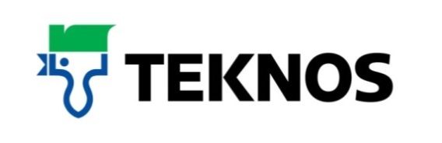

38784t
16 February 2018

PBM/TeknosPro company profile

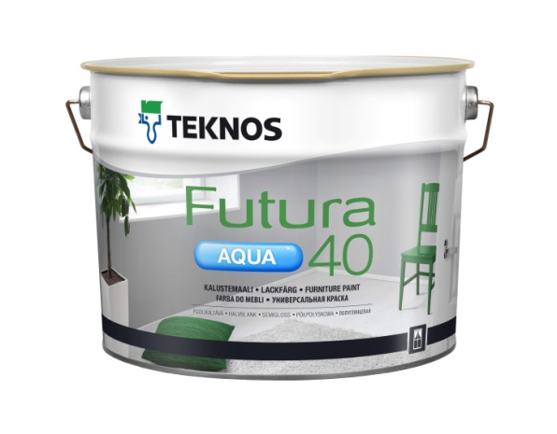

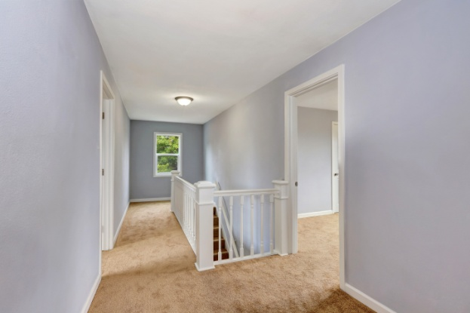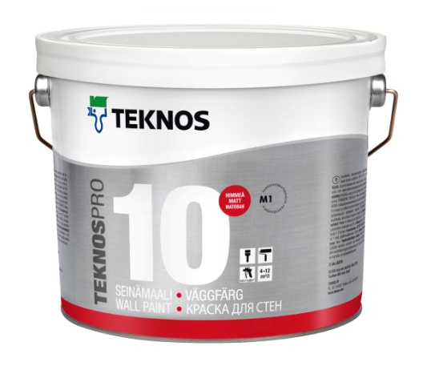

Teknos the company - https://www.teknos.co.uk

Established in 1948 when an old farm with a hen house was leased for the purposes of paint making, Teknos now operates in more than 20 countries in Europe, Asia and the USA, employing some 1,600 people. Among Finland’s largest family-owned businesses, it is one of Europe’s leading suppliers of specialist industrial and decorative coatings for manufacturing industries, building and decorating professionals and consumers.

With over 25 years in the UK joinery market, as well as a strong position in the retail and architectural markets, Teknos works in close cooperation with its customers, focusing on product quality and performance, while remaining committed to sustainability. Teknos actively chooses to develop water-based paints over solvent-borne for the lowest environmental impact.

Teknos invests heavily in research and development with the aim of offering smart, technically advanced, paint and coating solutions to protect and prolong. Factory applied coatings systems produced by Teknos are designed to give many years of life between re-painting cycles with all products providing highly durable finishes. Modern pigments are used and dispersed evenly through the paint and provide lasting colour that is fade resistant.

The wide range of paints and coatings offered by Teknos comply fully with European VOC emission standards and REACH regulations. The products are water-based and low to no odour; they do not contain lead, chrome or other heavy metal additives while manufacturing facilities hold IOS 9001 quality and ISO 14001 environmental certificates.

TeknosPro - https://www.teknospro.co.uk

Developed for professional decorators, TeknoPro is a range of multi surface products based on low odour, quick drying, water-based technology.

It includes specialist finishes for internal walls, metal and wood and is suitable for new build and maintenance projects. TeknosPro paints have excellent flow and can be applied by brush or roller.

Key features include: high coverage internal wall finishes, wipe clean paints for kitchens and bathrooms, superior wood and metal finishes suitable for inside or outside use, translucent finishes to maintain the natural look of wood doors, stairs and floors, and specialist primers to seal and protect difficult or problem surfaces.

Builders’ merchants play an integral part of the distribution network for TeknosPro. Independent and national builders’ merchants have been incorporating “decorating centres” within their depots for many years. This offers the one-stop-shop to decorating contractors, joiners, landscapers and building contractors. The builders’ merchant benefits from providing the complete product solution to the user and, in conjunction with Teknos, the brand can be promoted to various market sectors within a builders’ merchants.

Teknos manufactures translucent and opaque high-quality coatings, specifically designed for various surfaces; joinery (doors & windows), cladding, decking and fencing materials through to masonry, plasterboard, metalwork and internal & external joinery finishes.

In addition, to the extensive product range, Teknos can provide the Teknomix 50 Tinting System for the merchant who is looking to supply the contractor with a vast range of colours; from opaque colours, Teknos Colour Mode collection, British Standard and European Colour collections such as RAL and NCS. With Teknos technology, all opaque products, whether emulsions or gloss finishes, are tinted from two tinting bases thus reducing the stock holding of multiple tinting bases. TeknosPro provides a wide range of translucent shades from the Teknomix colour cards - from natural wood tones to deeper greens and greys for external timbers and soft pastel translucent shades for internal finishes. TeknosPro provides the technology and product solutions for today’s decorative finishes.

For further information, contact 01608 688925 or visit www.teknos.co.uk.

-ends-

Notes to editor

Teknos is a global coatings company with operations in more than 20 countries in Europe, Asia and the USA. It employs approximately 1,600 people. Teknos is one of the leading suppliers of industrial coatings with a strong position in retail and architectural markets. Teknos develops smart, technically advanced paint and coating solutions which protect and prolong the life of buildings, wood and metal. Teknos always works in close cooperation with its customers. It was established in 1948 and is one of Finland’s largest family-owned businesses.

With Compliments:-
Alison Relf
Taylor Alden Ltd
Unit 2, Temple Place
247 The Broadway
London
SW19 1SD
Tel: 020 8543 3866
Email: alison@tayloralden.co.uk

