

38733c

12 January 2018

**Protect your outdoor surfaces with TeknosPro’s Siloksan range**

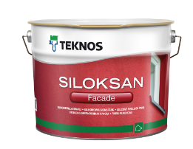 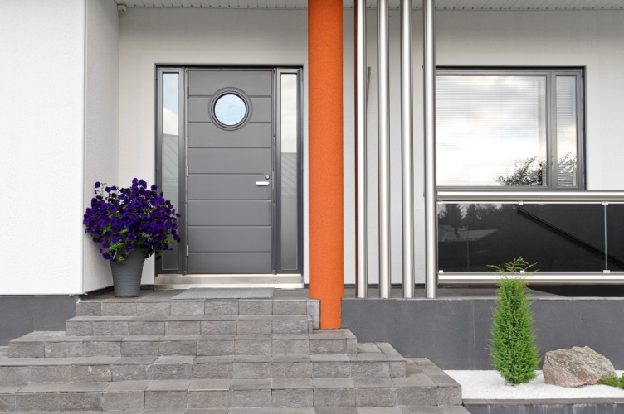

Perfect for reinforcing and protecting outdoor surfaces, TeknosPro’s [Siloksan Façade](https://www.teknos.com/en-GB/website/estonia/estonia-ac/valisvarvid-ac/siloksan-facade/) and [Siloksan Gel](https://www.teknos.com/en-GB/website/estonia/estonia-ac/valisvarvid-ac/siloksan-geeli/) coatings are ideal for use on concrete, plastered garden walls and other outdoor facades.

Siloksan Façade is UV light and heat resistant and, combined with water-repellent technology, ensures that your outdoor surfaces are protected from corrosion all year round. It does not require a separate priming coat when used in conjunction with Siloksan Gel which means there’s less work for you to do when renovating your outdoor space.  Siloksan Gel prevents rain and splash water from getting inside your surfaces so they remain well-protected and looking pristine.

For further information, contact 01608 688925 or visit [www.teknos.co.uk](http://www.teknos.co.uk).

-ends-

**Notes to editor**

Teknos is a global coatings company with operations in more than 20 countries in Europe, Asia and the USA. It employs approximately 1,700 people. Teknos is one of the leading suppliers of industrial coatings with a strong position in retail and architectural markets. Teknos develops smart, technically advanced paint and coating solutions which protect and prolong the life of buildings, wood and metal. Teknos always works in close cooperation with its customers. It was established in 1948 and is one of Finland’s largest family-owned businesses.

With compliments:

Alison Relf

Taylor Alden Ltd

Unit 2, Temple Place

247 The Broadway

London

SW19 1SD

Tel:  020 8543 3866

Email: [alison@tayloralden.co.uk](mailto:alison@tayloralden.co.uk)