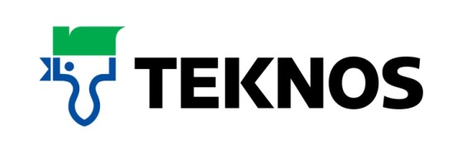
38589
19 July 2017

The durable water based alternative to oil eggshell paints
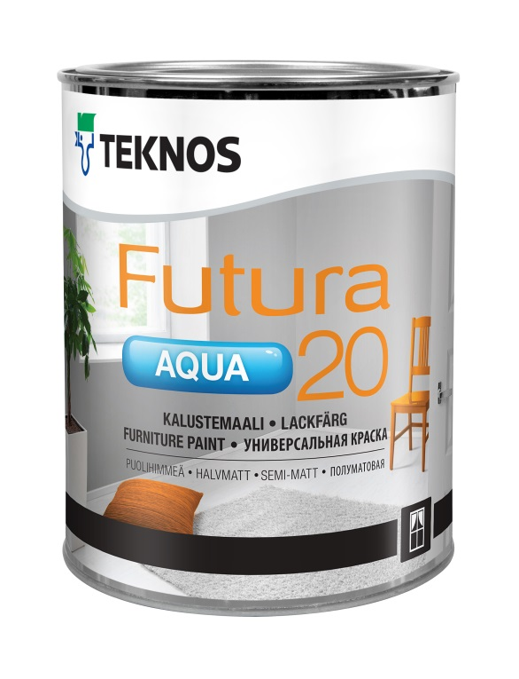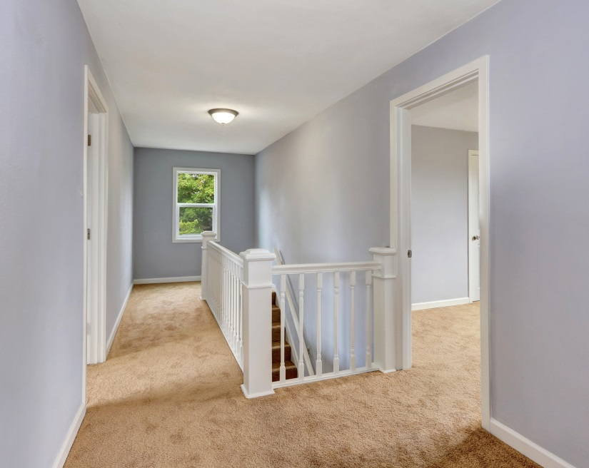

Ideal for joinery items such as furniture and paneling, Teknos Futura Aqua 20 is a semi-matt, waterborne urethane alkyd based interior and exterior paint. Suited to professionals requiring a hand-applied brush finish that flows easily with few brush marks, it provides a very low sheen top coat and incredibly durable surface.

Teknos Futura Aqua 20 is environmental-friendly with low VOC levels and can be used for a wide range of applications including interior doors, window casements, cabinets, mouldings, panels, staircase railings and radiators. It is also suitable for use outdoors on primed window casements and doors.

The modern pigments used in Futura Aqua 20 disperse evenly through the paint and provides excellent resistance to weather and UV rays, and they retain their colour and gloss over time. The paint may be thinned with water and is easy to apply by brush, roller and spray, which makes the application effortless. The surface is dust free after one hour and through-dry after two to three days.

Jan Jankowski of leading kitchen painter, JJ Painting Services, comments: “I needed an extremely durable paint. Teknos Futura Aqua 20 applied beautifully and, once cured, was very tough. I did the finger nail test by constantly trying to scratch away at the surface but there were no visible marks, which is not the case with most water based paints. Teknos Futura Aqua 20 is the water based alternative to oil eggshells, I’m very impressed!”

The Futura Aqua portfolio of waterborne finishes provides varying sheen levels with Futura Aqua 40 offering semi-gloss and Futura Aqua 80 gloss. The paints can be tinted to all Teknos colour shades and also available is the versatile Futura Aqua 3 primer. Package sizes are 0.9, 2.7, 9 litres.
-ends-

Notes to editor

Teknos is a global coatings company with operations in more than 20 countries in Europe, Asia and the USA. It employs approximately 1,700 people. Teknos is one of the leading suppliers of industrial coatings with a strong position in retail and architectural markets. Teknos develops smart, technically advanced paint and coating solutions which protect and prolong the life of buildings, wood and metal. Teknos always works in close cooperation with its customers. It was established in 1948 and is one of Finland’s largest family-owned businesses.
For further information contact 01608 688925 or www.teknos.co.uk.

With compliments:

Alison Relf
Taylor Alden Ltd
Unit 2, Temple Place
247 The Broadway
London
SW19 1SD
Tel: 020 8543 3866
Email: alison@tayloralden.co.uk

