38637
7 September 2017

TeknosPro – Professional paint at its best
National Painting and Decorating Show, Ricoh Arena Coventry, 28 – 29 November 2017. Stand 104

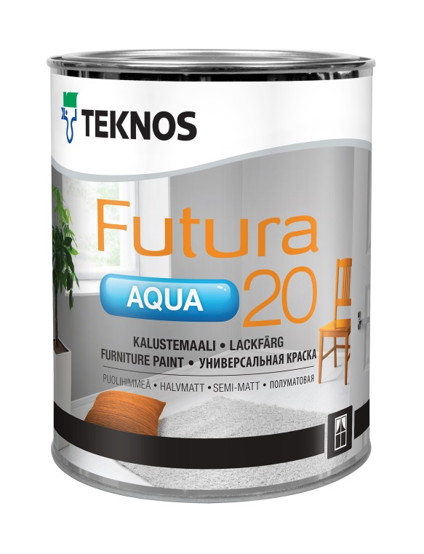
TeknosPro will display a selection of outstanding industrial and decorative paints and coatings at this year’s National Painting and Decorating Show.
TeknosPro offers smart, technically-advanced solutions that protect and preserve wood, walls and metal. Factory-applied systems are designed to give many years of life between re-painting cycles and all products provide highly durable finishes.
Pictured is TeknosPro’s Futura Aqua 20 semi-matt, waterborne urethane alkyd based interior and exterior paint. Suited to professionals requiring a hand-applied brush finish that flows easily with few brush marks, it provides a very low sheen top coat and a long-lasting surface. The whole Futura Aqua range will be displayed at the show along with the rest of the TeknosPro portfolio.
For further information, please call Teknos on 01608 688925 or visit www.teknos.co.uk.

With compliments:
Alison Relf
Taylor Alden Ltd
Unit 2, Temple Place
247 The Broadway
London
SW19 1SD
Tel: 020 8543 3866
Email: alison@tayloralden.co.uk

