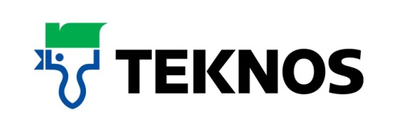
38593
21 September 2017

A modern paint with traditional style
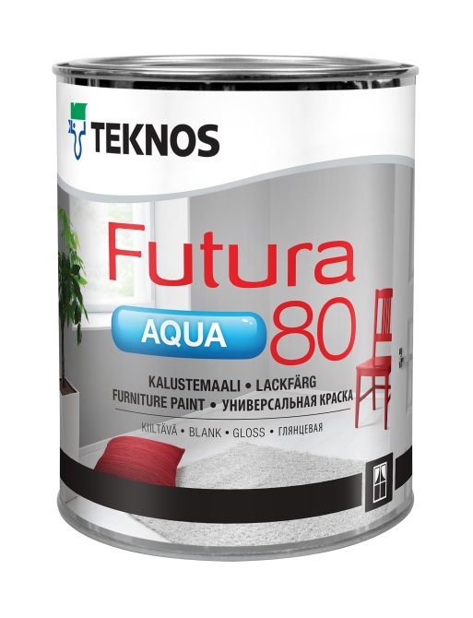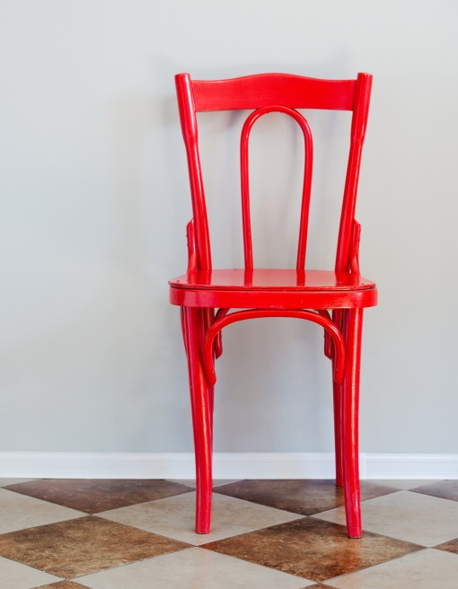

Providing an extremely high gloss finish that replicates the look of traditional oil-based products, Teknos Futura Aqua 80 is a waterborne paint so is a popular choice in conservation areas where products better suited to today’s environment are required. The highly versatile paint retains its appearance and can be used on doors and other joinery as well as furniture and metalwork, including railings and radiators.

Teknos Futura Aqua 80 is a waterborne urethane alkyd based top coat designed for interior or exterior use and offers an incredibly tough finish on wood, metal and building board surfaces. Environmentally-friendly and complying fully with European VOC emission standards and REACH regulations, it has low VOC levels and no odour.

The paint can be thinned with water and is easy to apply by brush, roller and spray. It flows well, leaves few brush marks and does not drip; the surface is dry after one hour and through-dry after two to three days. Clean up is with appropriate detergent and warm water.

A key feature of Futura Aqua 80 is its durability. It can be tinted to most colour shades and the modern pigments used disperse evenly through the paint to provide lasting colour that is fade-, weather- and UV-resistant.

The Futura Aqua portfolio of waterborne paints provides varying sheen levels and comprises Futura Aqua 20, which offers a semi-matt finish, and Futura Aqua 40 with a semi-gloss finish. The range is complemented by the versatile Futura Aqua 3 primer and is available in 0.45 0.9, 2.7 litre sizes.

-ends-

Notes to editor

Teknos is a global coatings company with operations in more than 20 countries in Europe, Asia and the USA. It employs approximately 1,700 people. Teknos is one of the leading suppliers of industrial coatings with a strong position in retail and architectural markets. Teknos develops smart, technically advanced paint and coating solutions which protect and prolong the life of buildings, wood and metal. Teknos always works in close cooperation with its customers. It was established in 1948 and is one of Finland’s largest family-owned businesses.
For further information contact 01608 688925 or www.teknos.co.uk.

With compliments:

Alison Relf
Taylor Alden Ltd
Unit 2, Temple Place
247 The Broadway
London
SW19 1SD
Tel: 020 8543 3866
Email: alison@tayloralden.co.uk

